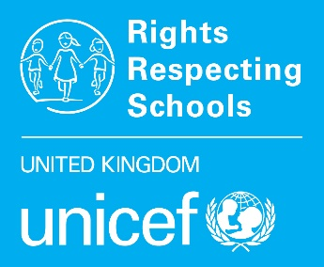
RRSA QUESTIONNAIRE FINDINGS
Please return these figures to your Professional Adviser with your Bronze, Silver, or Gold accreditation paperwork.

Pupil Questionnaire Findings

 | School name:
 | Number of pupils completing questionnaire:
 |  |  | % of pupils
 |  |  | Yes | Sometimes | No | Not sure | No answer
2 | I learn about my rights at school
3 | I enjoy being at school
4 | I feel safe at school
5 | Adults treat me with respect
6 | Pupils are kind and helpful
7 | If I felt unsafe, I could tell an adult
8 | My teachers listen to me
9 | I can influence decisions
10 | I know how to make progress
11 | In general, I like the way I am
12 | I can do things to help locally
13 | I can do things to help globally

 |  |  |  |  | % of pupils
 |  |  |  |  | Yes | No | Not sure |  | No answer
14 |  |  | Parents
 |  |  | Wider family
 |  |  | Other adults
 |  |  | Other children
For secondary pupils only…
15 |  |  | Shared on social media?
 |  |  |  |  | 1-2 | 3-5 | 6-10 |  | 11+
 |  |  | How many times?
 | School name:
 | Pupil Questionnaire Findings
 |  | School name:
 |  | Number of pupils completing questionnaire:

Staff Role | Number of participants

 |  |  | % of adults
 |  |  | Strongly agree | Agree | Disagree | Strongly disagree | Not sure
1 | I am treated with respect by other adults
2 | I am treated with respect by pupils
3 | I feel comfortable talking to pupils about rights
4 | I enjoy working at this school
5 | Pupils are actively engaged in school life
6 | Pupils can influence decisions made in school

